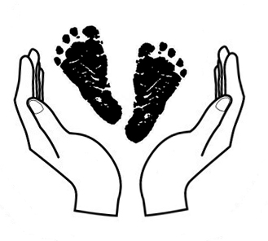
Help us serve you better.
Complete the following survey and return to us at:
317 West 1st St, Suite 111
Oswego, NY 13126

Date:_________________________

Name:_____________________________________________________________________________
Address:___________________________________________________________________________
City:______________________________________________ State:_________ Zip:_______________
Phone:___________________________ E-Mail:___________________________________________

Care needed for how many children?________________ Ages:___________________________

1) Would you use CCR&R services again or refer others to us? Yes No Maybe

2) Client satisfaction with CCR&R services:
Counselor Helpful Referrals/Information Somewhat Accurate
Counselor Somewhat Helpful Referrals/Information Not Accurate
Counselor Not Helpful Referrals/Information Somewhat Helpful
Referrals Helpful Subsidy Information Helpful
Referrals Somewhat Helpful Subsidy Information Not Helpful
Referrals Not Helpful Subsidy Information N/A
Referrals/Information Accurate

3) Satisfaction Notes: _________________________________________________________________________________________________________________________________________________________________________________________________________________________________________________________

4) Search Outcome:
Found Care Care Not Found Have Not Completed Search Kept Current Provider/Arrangements
Care No Longer Needed On Provider Waitlist

5) How did you find care?
CCR&R Referrals Parent Portal
Other Agency Friend/Relative Recommendation
Social Media/Provider Website Other Referral Service
Internet/Self Search Other_________________________________

6) Reason for Choosing Provider:
Child/Staff Ratio Facility Environment
Group/Class Size Children Appeared Happy
Family Involvement Location
Caregiver Education Schedule of Care
Curriculum Caregivers/Staff Attentive to Children
Learning Environment Program Accredited
Child Assessment Cost
Health & Safety

7) Type of Care Found:
Camp Child Care Center Early Head Start
Family Child Care Friend/Relative Group Family Child Care
Head Start in Home Legally Exempt
Patchwork Playgroup Nursery School
Pre K/Preschool School Age Program Universal Pre K

8) Problem Finding Care:
Cost of Care Too High Provider(s) Not Responsive
Cultural Differences Special Needs Could Not Be Accommodated
Dissatisfied w/ Quality of Care Provided Subsidy Not Accepted
Language Barrier Transportation
Location of Care Type of Care Desired Not Available
No Openings for Child/Children Other________________________________
Provider Not Available During Days & Hours Needed

9) Problem Notes:
_________________________________________________________________________________________________________________________________________________________________________________________________________________________________________________________

10) Employment Outcome:
Lost Job Due to Child Care Issues Changed Shifts to Accommodate Child Care Schedule Decided to Stay Home Working Fewer Hours
Child Care Did Not Impact My Job Changed Jobs to Accommodate Care Schedule
Was Able to Get/Keep a Job Because of Finding Child Care
Wasn't Able to Get/Keep a Job Without Child Care

